
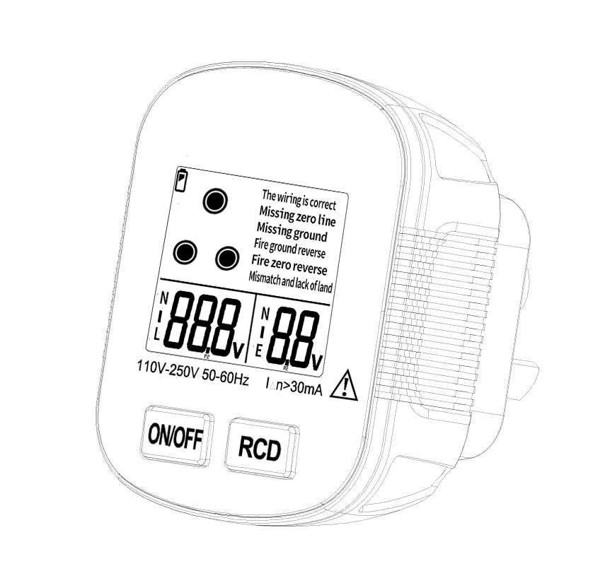
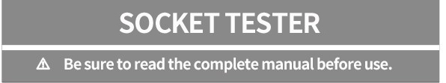
I. Introduction
This product is mainly used for the polarity detection of the three-hole power socket wiring and the protection function detection of the leakage switch. It can quickly and accurately detect the wiring condition of the socket, and can timely detect the socket lines that cause electric shocks, electrical fires, and abnormal equipment operation. question. It is widely used in fire protection, safety supervision, home improvement, laboratory, factory and home line inspection and maintenance.
Warning: Please read the instruction manual carefully before use, and strictly abide by the safety rules and the caution, attention, warning and other matters listed in the instruction manual. To avoid possible electric shock or personal injury:
· Before use, please check the tester carefully to confirm whether it is damaged, if it is damaged, please stop it immediately
Stop using it and send it in for repair.
· To test whether the tester is correct, plug the tester into a known correct socket to test.Check that the test function is correct and use it later.
· When testing the switch detection, it can only be used normally if the wiring is correct.
· When testing the leakage switch, please turn off the equipment on the power line to ensure that the power failure will not cause any harm. When testing in public places, the test must be approved.
· When using, if the socket wiring error is detected, please ask a professional electrician to repair the wiring.

II. Technical Parameters
Zero-live voltage measure（L-N） | 30-250V/ (50-60HZ)
Zero-earth voltage measure（N-E） | 0.1-10V /(50-60HZ)
Working environment | Temp 0℃-40℃ / humidity (20℅-70℅)
Storage environment | Temp 10℃-50℃/ humidity(20℅-80℅)
RCD Current | >30mA
RCD Working voltage | 220V ± 20V
Battery | AAA X 2
Weight
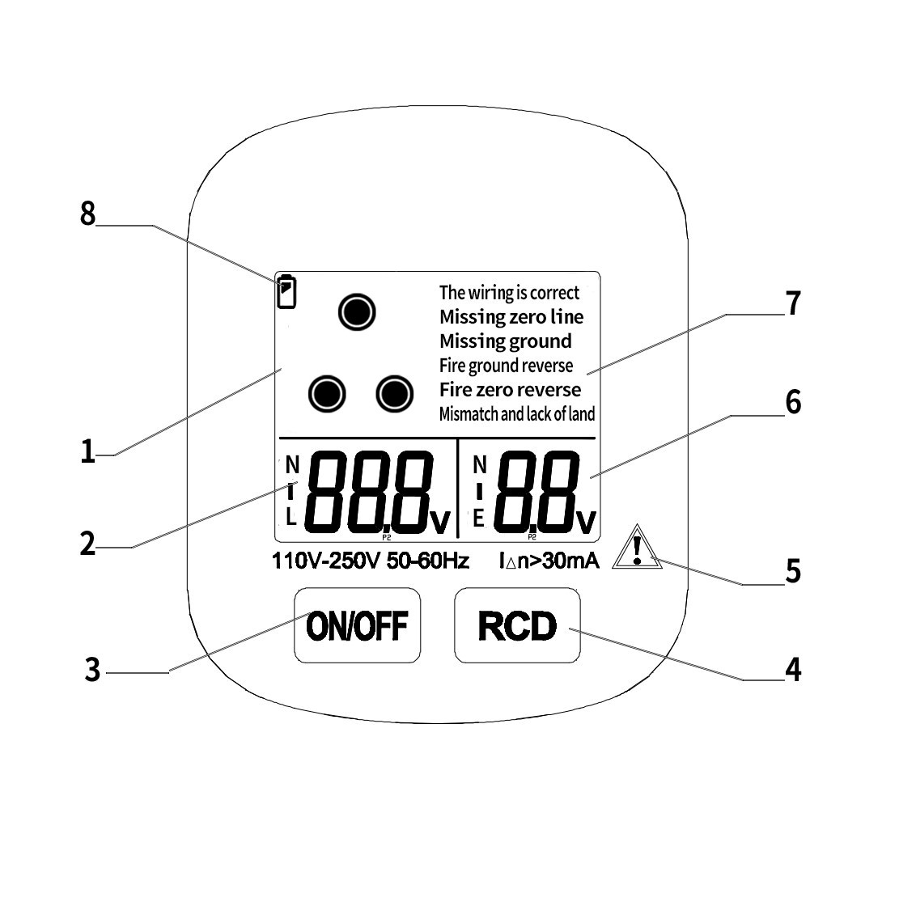
III. Panel Introduction
1. socket pin indication
2. Zero-live voltage test
Value display
3.Power on/off
4.RCD leakage current
Test button
5. warning symbol
6.Zero-earth voltage test value display
7. Socket wiring status display area 8.Low battery indication
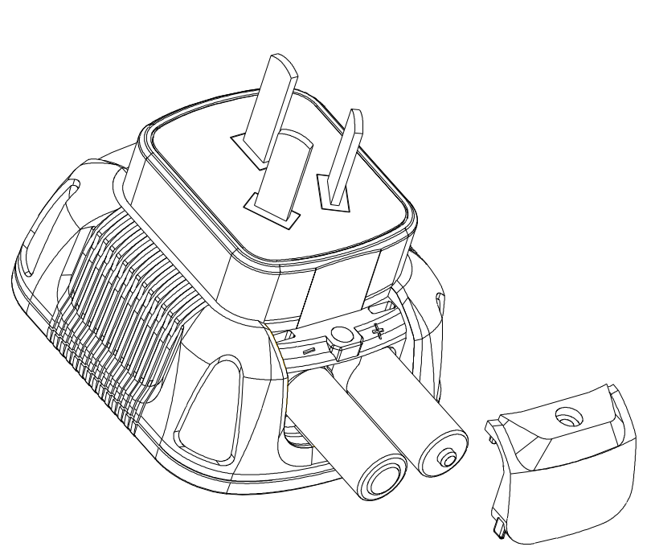
IV. Operation Introduction
1.Before using, please open the
battery cover ,Install two AAA
batteries. (shown as right)
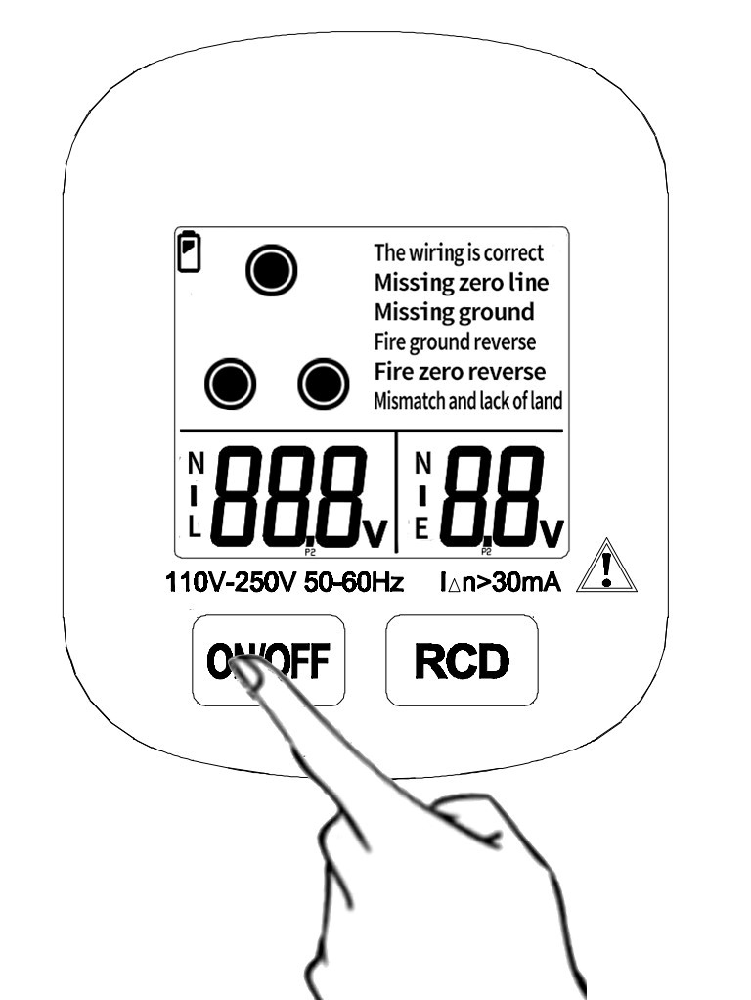
2. Long press the power button for
2 seconds, then it is power on.
(shown as right)
3) Plug the product into the socket
to be tested to test the current socket line status and voltage.
Test status analysis：
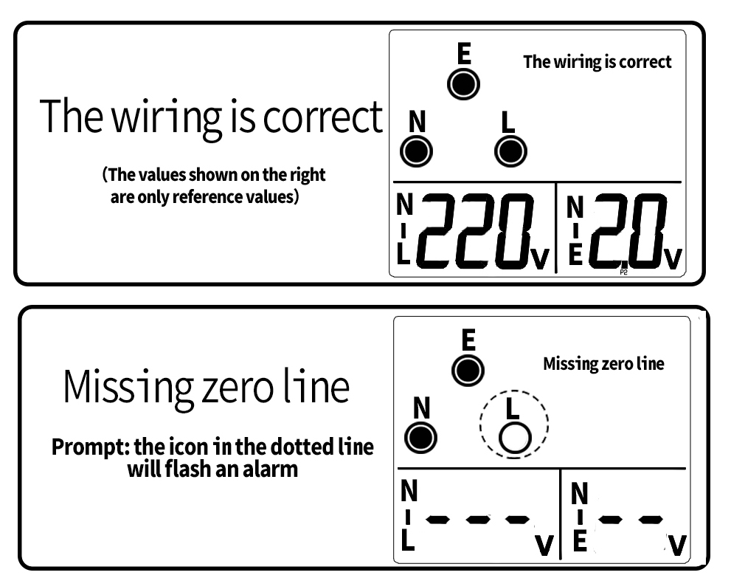

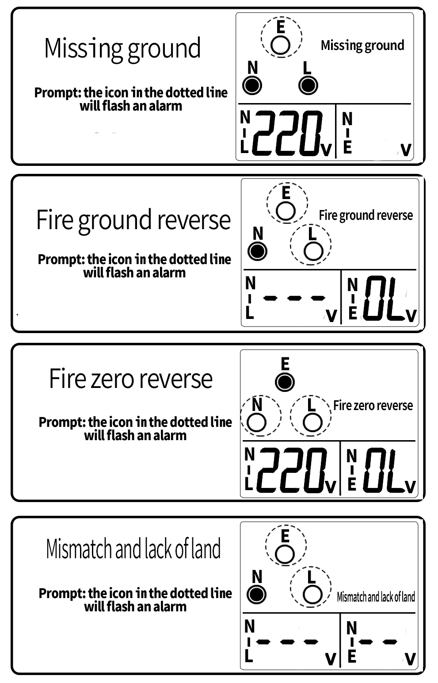

Special attention：
1. The normal voltage range of zero fire line is plus or minus 10% of the local standard voltage. If it is too high or too low, it may be because the circuit load is too high or the power supply is too low / too high.
2. The normal voltage of zero-earth wire is less than 2V, if too high maybe it is because there is current leakage, or the three phase-sequence is out of balance or there is signal interference in the circuit.
V. RCD TEST
Warning：Please turn off all electrical appliances before using this function, and do so with permission to ensure that the power outage will not cause any harm.
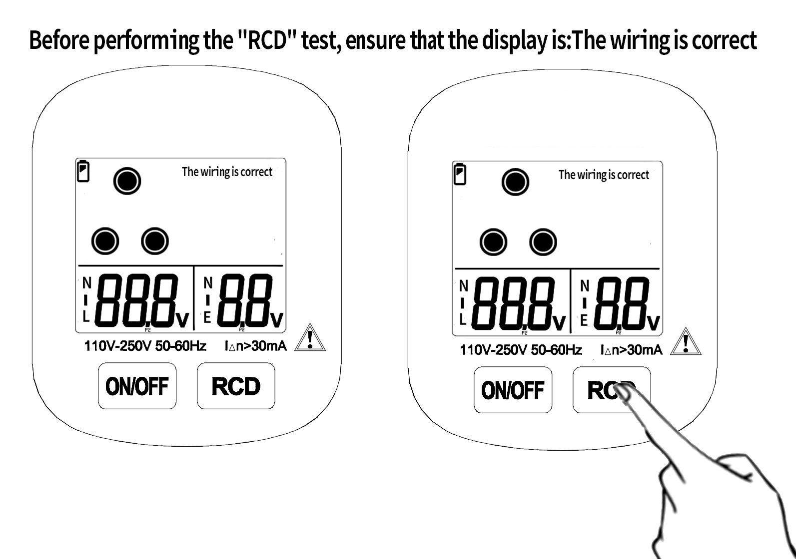

Insert the tester into the three-hole socket, and make sure to press the RCD button when the display prompts "correct wiring" (pressing time is less than 3 seconds), then the normal leakage switch will trip. Indicates that the leakage switch has failed or is missing. Please seek professional electrician maintenance in time.

VI．Battery replacement
In order to avoid personal electric shock or injury due to wrong readings, when the battery undervoltage symbol “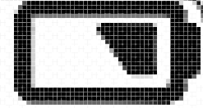 ” appears on the meter, be sure to replace the battery immediately.
To avoid electric shock or personal injury, always turn off the power and confirm that the socket tester has been removed from the measurement circuit before opening the battery cover to replace a new battery.
VII. Accessories
1.AAA batteries……………2pcs
2.User manual………………1pc
3.Warranty card……………1pc

Warranty
This product is guaranteed for 18 months from the date of purchase. Fuses, disposable batteries and accessories such as packaging boxes or damage to the instrument due to accidents, neglect, abuse, alterations, pollution, and abnormal operating conditions are not covered by the warranty.
This manual is subject to change without notice.
The contents of this manual are considered to be correct. If the user finds errors etc please contact us.
The company is not responsible for accidents and hazards caused by user's wrong operation
The functions described in this manual should not be used as a reason to use the product for a special purpose.

